Pearl Grlz Survey Application

- Pearl Grlz Survey
- Pearl Grlz Survey Implementation
- Future enhancement

- Pearl Grlz Survey:

The survey includes several types of questions: 1) individual activities questions, 2) partner related questions.

The following screen shots show the survey questions in more details:

→ Individual Activity Qeustions:
 | Individual Activity Questions
 | [Which of these things have you done since your last prompt…] [CheckList_IndividualActivityQuestions] |  | Categories | Value
D | Went to school | SCHOOL | Yes | 1.00
D | Skipped school | SKIP | Yes | 1.00
D | Did homework | HOMEWK | Yes | 1.00
D | Played a video game | GAME | Yes | 1.00
D | Took a nap | NAP | Yes | 1.00
D | Listened to music | MUSIC | Yes | 1.00
D | Hang out with friends | HANGFR | Yes | 1.00
D | Hang out with family | HANGFA | Yes | 1.00

→ Partner Interaction Questions.
 | Partner Interactions - if PTRINT1 or PTRINT2 = YES, each partner
 | Which of the following did you do today with [PARTNER NAME]? Checklist like activities above
D | Talked to on phone | PTRTALK | Yes | 1.00
D | Texted | PTRTEXT | Yes | 1.00
D | Talked to at school | PTRSCHOOL | Yes | 1.00
D | Spent time outside of school | PTROUTSIDE | Yes | 1.00
D | Chatted or talked to online | PTRONLINE | Yes | 1.00
D | Viewed your social networking page (like MySpace, Facebook, other) | PTMYSPACE | Yes | 1.00
D | Had vaginal, oral or anal sex | PTRANYSEX | Yes | 1.00
W | Sent a nude photo of yourself | PTRPHOTO | Yes | 1.00
W | Sent a sexual text message | PTRSXTXT | Yes | 1.00

Because the partner related questions will be asked for up to three partners, there are more than four hundred and fifty questions.

- Pearl Grlz Survey Implementation:

The survey is implemented by using OpenMRS open source. The survey data results are saved in MySQL database.

The answers to the questions are saved into obs table in MySQL. The concept, concept_name, concept_answer tables support the Pearl Grlz Survey questions and answers saved in obs table. There are more than five hundred concepts created to support Pearl Grlz Survey.

The application uses Spring Framework to implement the business Services, it uses Hibernate for the business services to connect to the EIS data store.

The user-interface design uses Spring MVC framework. The View technology uses the Java Server Page.

The following screen snapshots show the presentation of the survey:

→ Login page

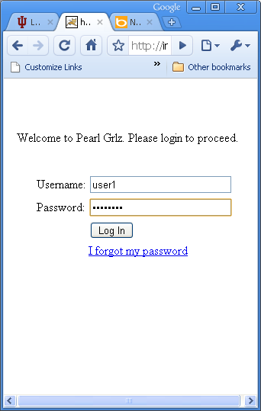

→ Yes/No Questions:

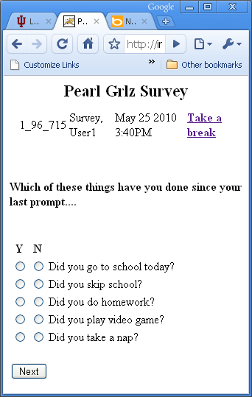

  - Selection questions:

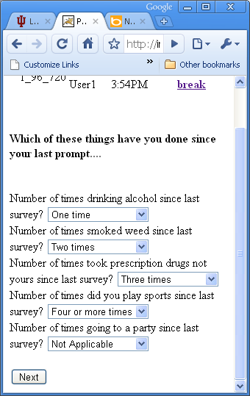

→ Text Inputs and Selection combined interface

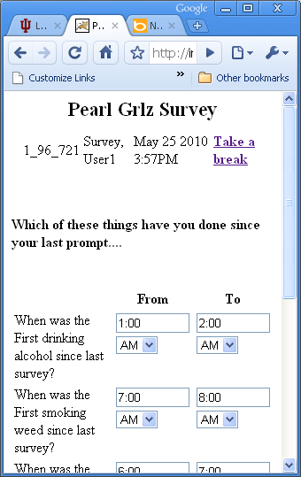

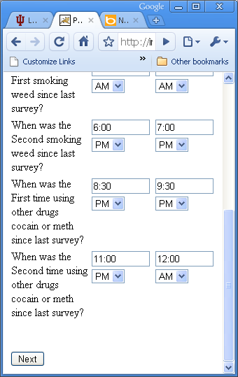

→ Text Input for partner names:
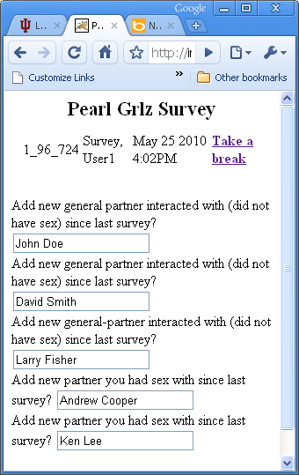

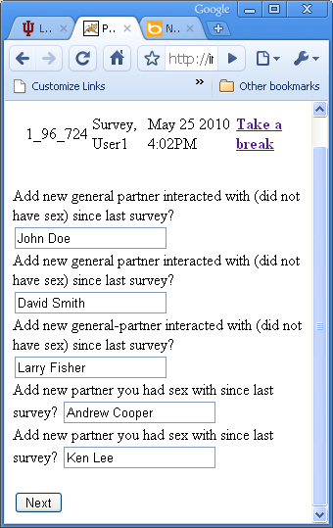

  - Select partner page:

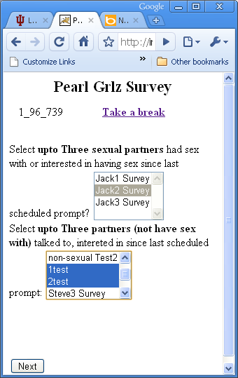

→ Partner related questions (for the individual partner)

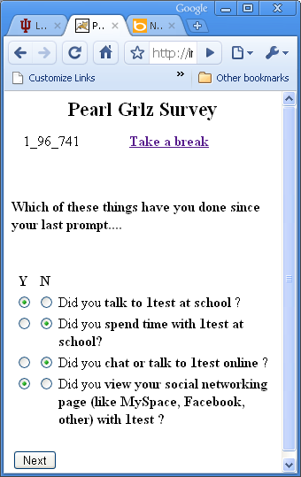

  - Partner related Questions (time and location)

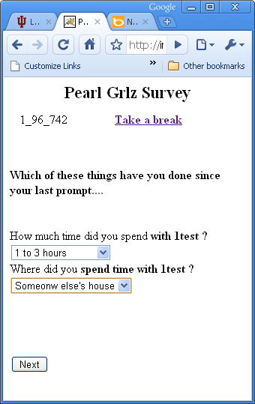

  - The final page indicating survey completion:

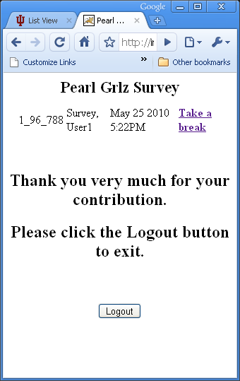

- Future Enhancement:

1) Add a "Back"/”Prev” button to all the pages so that users can correct the answered questions.

2) Add ONE slider for the pages which requires users to input time-ranges (eg, from 6:00am to 7:30am). And use this slider to control the input of all the input places. Also, need to make sure the value of the range should NOT greater than four hours. (Please refer to the GUI snapshot in the below for reference)

3) Logically group the questions together, for questions: “How many times did you drink alcohol?” and the following time-related questions “What’s your first time drinking alcohol?”, “What’s your second time drinking alcohol?”, etc.

The nature of the time-related questions is that they depend on the users-answer to the how-many-times question: if the user replies two-times, then we will as two time-related-questions, if the user said four-times, then we ask four time-related-questions.

Currently, to work around the Chica’s batching-processing-MLM-rules (what Chica currently does is to evaluate several number of rules in a batch mode. That prevents Pearl-Grlz from implementing the above logic).

The current workaround is to ask ALL how-many-times questions altogether, and then time-range-related-questions later on to make sure we have the correct number of questions to ask.

However, this workaround breaks the logic grouping for such type of questions. Once Chica batch-processing-MLM-rules logic gets changed, Pearl Grlz can then logically group those questions.

4) Performance, need to increase the survey responding time. Need to revisit how much time for the MLM to execute, and check the Network traffic time.

5) For inputting the time (or any other number related UIs), let's make the Keyboard show numbers by default

6) Need to test all the MLM rules. Update the question prompts as needed.

7) On the Delete-partner-page, showing all partner names, and having "Radio" Buttons for each name, so that users can delete or not ...

  - For the user input for the time, use the slider to select time range, this will save a lot of time that users will spend on typing ….

➔ Old input: ➔New Input:
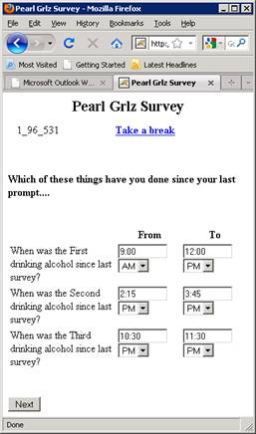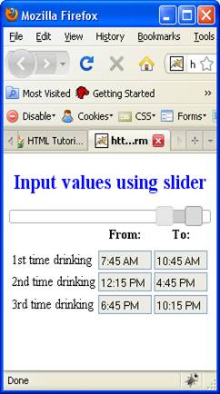

Revision | Author | Description | Date
1.0 | Jun Wang | Initial check-in | 05/26/2010

